MODERN OPERATING SYSTEM AND COMPUTER NETWORK
ASSIGNMENT -3
NAME:Shreemayi Katakam
ROLLNUMBER:2503B05124(M.TECH-CSE)

Task:1
Problem-01:
A bit stream 1101011011 is transmitted using the standard CRC method. The generator polynomial is x⁴+x+1. What is the actual bit string transmitted?

CODE:
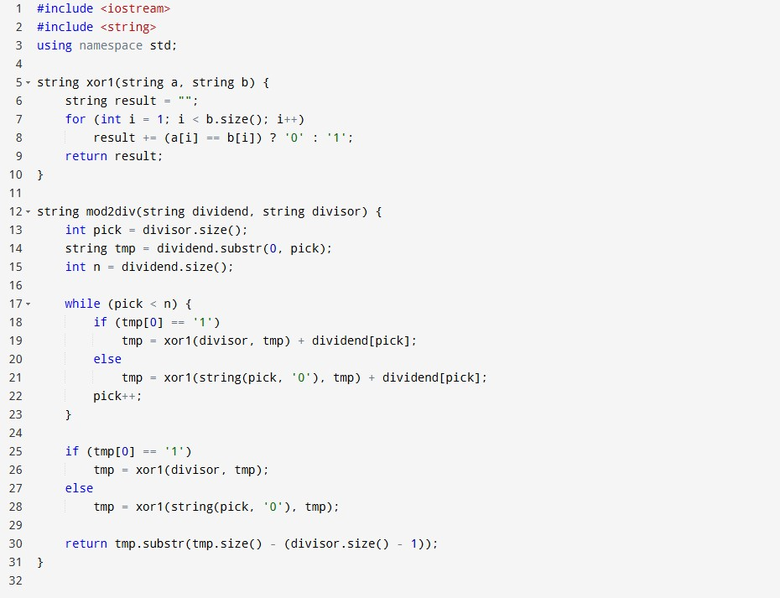
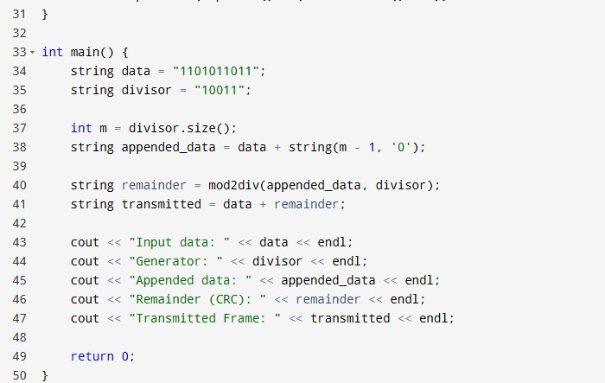

OUTPUT:
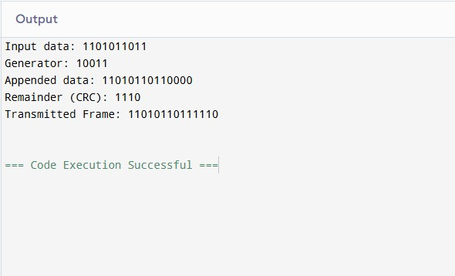

Task:2
Problem-02:
A bit stream 10011101 is transmitted using the standard CRC method. The generator polynomial is x³+1.

- What is the actual bit string transmitted?
- Suppose the third bit from the left is inverted during transmission. How will receiver detect this error?

CODE: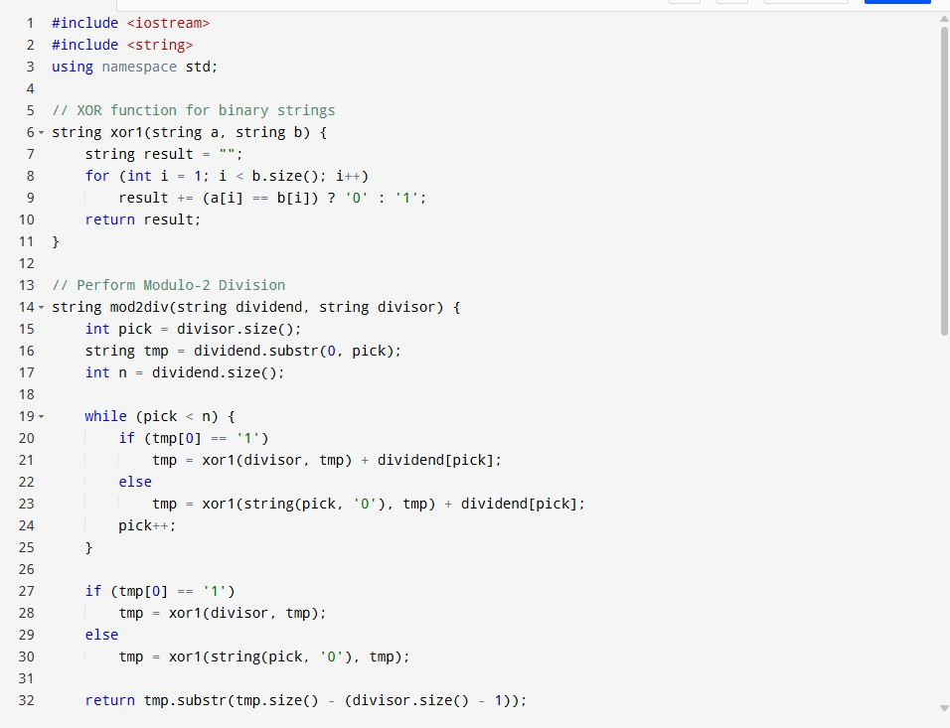

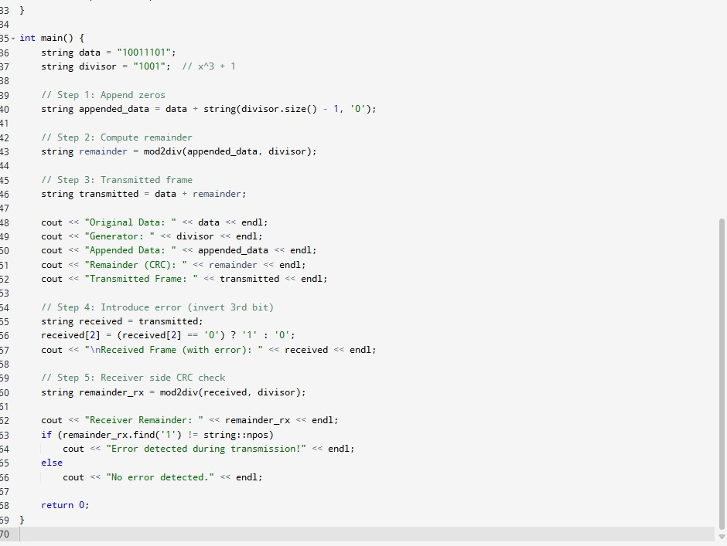

Output:
